Experiment-19
Aim:
To write a Prolog program to create a database containing student names, teacher names, and subject codes, and retrieve the details using queries
Algorithm:
- Start the Prolog program.
- Define facts containing student names, teacher names, and subject codes.
- Create a rule to display all database records.
- Create a rule to search for a student and retrieve the corresponding teacher and subject code.
- Load the program into the Prolog interpreter.
- Execute the required query.
- Display the results.
- Stop the program.
Code:
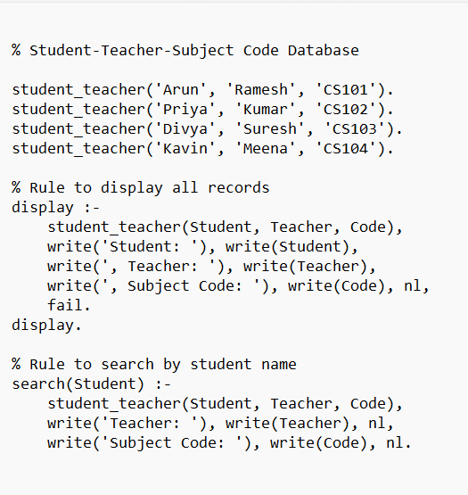

Output:
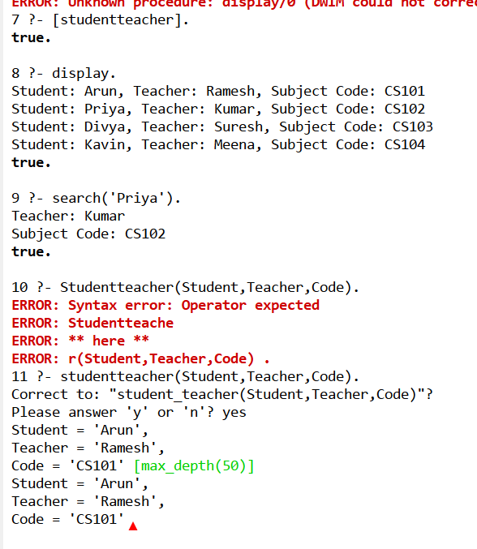
Result:
Thus the prolog program to create a database containing student names, teacher names, and subject codes, and retrieve the details using queries

